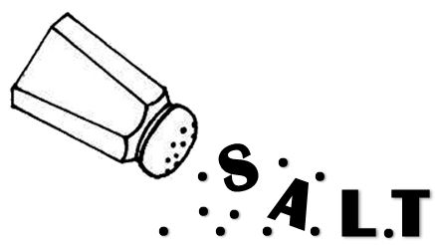
Prop Circle
skill

GOAL: To think fast on your feet and be able to switch into character quickly.

SET-UP: Have participants stand in a circle. Have a bag with 3-4 items that can be used as a versatile prop (towel, serving tray, clipboard, etc)

EXERCISE: The leader will pull out an item and slip into a character using the item as a prop. The leader will turn and address the person to his right. For example – the leader may pull out a towel and put it over his arm, turn to the person on his right and says in a French accent, “Have you decided what you will have for your first course? – I recommend the sautéed frog legs with, hmmm, maybe a dry white wine.” The person who is being addressed then takes the towel and does something completely different with it – maybe uses as a bullfighter flag and responds in a Spanish accent, “ I don’t have time to order now – can’t you see I’m busy!!?? I am sure your frog legs are excellento, but I will have to wait til later – if there is a later.” Then the bullfighter turns to the person on her right and says, “Hey, move out of the way – what are you doing here? – it is dangerous!” The next person takes the towel and the game continues. If it is too hard to make the people connect with both those before them and those after, just ask the students to interact with the next person and not worry about responding to the person before them.

